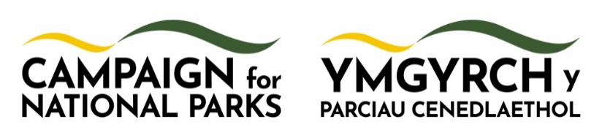

Marine Project Manager
£35,000 – 38,000 per annum
Fixed term: 18 months (with possible extension subject to funding)
Full time (35 hours per week)
Hybrid working, based in Pembrokeshire with occasional UK travel.

Campaign for National Parks is seeking a Marine Project Manager to lead an ambitious new project in one of Wales’ most exceptional coastal landscapes.
About Campaign for National Parks
Campaign for National Parks is the independent charity dedicated to securing the future of National Parks in England and Wales. Our independence from government means we can speak out for these landscapes when no-one else can. Our mission is clear: we’re here to unite, inspire and empower. Our vision is nature-rich National Parks for everyone.
About the project
Campaign for National Parks has launched a new marine project, working with Pembrokeshire Coast National Park Authority and a wide range of partners.
Pembrokeshire’s coast is outstanding: its seas support rich wildlife and deep cultural connections, yet many marine protected areas remain in poor condition. This collaborative, evidence-led project explores how better joined-up planning across land and sea could deliver improved outcomes for nature and people. Working closely with local communities and stakeholders, the project will consider a range of options — including the potential seaward extension of the National Park or designation of a Marine National Park — to help ensure Pembrokeshire’s coast and seas thrive for generations to come.
The project, funded by Esmee Fairbairn Foundation, will build on interest across Wales and England and include supporting the National Marine Park Alliance. It will work with young people to connect their passion for the sea and develop leadership skills, ensuring their voices help shape decision making.
About the role:
As Marine Project Manager, you will lead delivery of this pioneering project to explore how nature and communities can be supported through integrated land and sea planning and management.
Hosted by Pembrokeshire Coast National Park Authority, the role offers a unique opportunity to work at the heart of one of the UK’s most distinctive coastal and marine environments.
You will be the marine lead for the Campaign for National Parks team, working across programmes, advocacy, policy, campaigns, communications and fundraising.
About you
You will bring:
- Excellent partnership and relationship-building skills
- Passion for the sea and ability to spark excitement about the project
- Proven experience managing complex projects
- Strong self-organisation and initiative
- An understanding of social justice, including appreciation of Welsh language and culture.

Equity, diversity and inclusion
We recognise that the environment sector is under-represented by people of
colour, those from low-income backgrounds, LGBTQ+ and disabled people. We
want to change that and warmly welcome applications from people from all backgrounds. We can offer support with the recruitment process (including reasonable adjustments) to ensure everyone can apply on an equal footing. If you would like support, please contact recruitment@cnp.org.uk

Closing date: Tuesday 2 June 2026 (end of day)
Contact: recruitment@cnp.org.uk

How to apply
Please send the following documents to recruitment@cnp.org.uk
- Your application form – this will be the primary way we shortlist candidates.
- Your CV
Please also complete this anonymous Equal Opportunities Monitoring Form
It’s important to us that our application process helps us find the best candidates improving diversity by levelling the playing field. This is why our application form is focused on the skills needed to do the role and part of our inclusive recruitment practices – please do not include any personal information such as your name or age on your application form.
Unique Identifier:
Please create a unique reference using the day of the month you were born and the first four characters of your home postcode (e.g. 26-PO16). Please also ensure this Identifying code is included on your CV / cover email.

-

What is your notice period? (if applicable):

Application questions
Please answer the questions below. Your responses will be assessed anonymously against the essential skills and experience for the role.
Maximum 200 words per question. We will not score content beyond this limit.
What we’re looking for:
- Clear, specific examples
- Your actions and decisions
- What you learned or achieved
- Evidence of the skills described in each question
We will shortlist candidates based on the answers to these questions so you should ensure that all relevant information about why you are right for this role is included.
We welcome clear and authentic answers grounded in your real experience. Generic responses may not score well. Please answer in your own voice.

1. Motivation for the role and passion for the sea
What aspects of this role and project most motivate you, and how do they align with your experience and the kind of impact you want to have in your work?
Assesses: passion for the sea, alignment with role, clarity of purpose.

2. Partnerships and inspiring Others
Describe a time when you brought together people or groups with different perspectives to work towards a shared goal. How did you build trust and help others feel engaged or excited about the work?
Assesses: relationships, collaboration, communication, ability to inspire.

3. Project management and leadership
Describe a time when you led a project with multiple workstreams or partners. How did you plan the work, manage risks or resources, and ensure progress? What did you learn that you would apply to this role?
Assesses: project management, leadership, planning, risk management, reflection.

4. Social Justice, Inclusion
Describe a time when you ensured that inclusion, equity or social justice shaped the way a project or engagement activity was delivered. How did you take account of local culture or context in your approach?
Assesses: social justice, inclusive practice, cultural awareness (including Welsh context).

